**Memory Allocation:**

Above snippet shows the memory layout, the fields in above image are:

* text-text field(Instructions are stored)
* data-Data segment(global/static variables are stored)
* bss- Uninitialized data segement

There are 3 ways to declare a string

1. **Using character array with/without size limit:** Both the approach help in string manipulation

a. global initialization:

From both the above snippets we get to know that 13 bytes the memory for the string is allocated in data segment.

b. Local initialization:

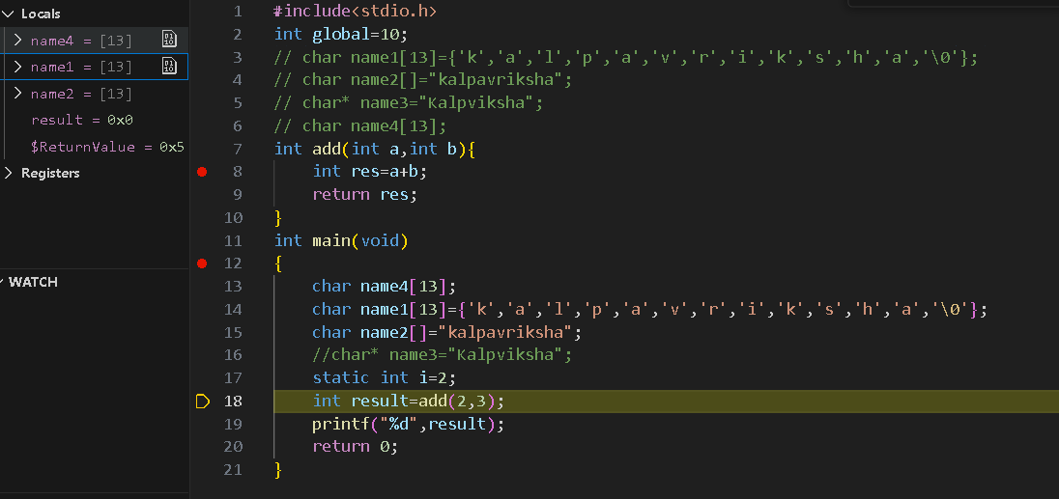

In both the ways of string initialization, the memory allocated in the stack

Difference: In First approach with size limit, the null terminator is explicitly added by programmer whereas this is not required in second approach.

**2. Using Pointer:**

Above snippet, helps us understand that globally initialized pointer is allocated 8 bytes of memory in data segment.

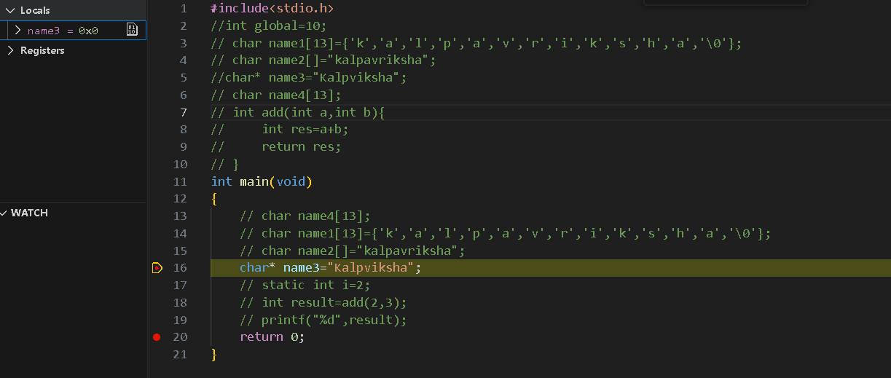

In case of local initialization, the pointer is given memory in stack as shown below in snippet. In both the case the string literal is in read only memory.